**D. Y. Patil Technical Campus,**

**Faculty of Engineering & Faculty of Management, Talsande**

**Department of Computer Science & Engineering**

**Course Name: Domain Specific Mini Projects**

**Class: TY**

**Division: A Batch: T3**

**Team Members:**

|  |  |
| --- | --- |
| **Roll No.** | **Name of Student** |
| 3057 | Vishal Vitthal Lohar |
| 3059 | Abhishek Sambhaji Patil |
| 3060 | Purushottam Santosh Patil |
| 3067 | Prasad Sanjay Shinde |
| 3071 | Suhas Shivanand Uttare |
| 3073 | Omkar Sajay Yadav |

**Project Guide Name: prof. B.S Jadhav**

**Synopsis Report**

**Project Title: Shopping Management System**

**Introduction:**

On-Line Shopping System” is a web-based project which is made for remote-shopping or shopping through Internet. As the technology is being advanced the way of life is changing accordance. Now a day’s we can place the order for anything from our home. There is no need to go the shop of the things we want. The order can be placed online through Internet. The payment, the confirmation of purchasing; we can do everything we want. Now we can think that how the days have been changed with time. People had to stand in rows to wait the terms to buy a particular thing from a popular shop. But what is happening now a day’s; we can extremely surprise that those things can be available on the door-step in few hours

**Objectives:**

* It’s providing the full details about the product and related formation about the product like cost, size etc.
* With the help of it we can save the time and money also.
* It provides the remote shopping by the cash, or DD, or Debit card also
* user-friendly interfaces for both customers and administrators, enhancing the overall usability of the system.

**System Architecture:**

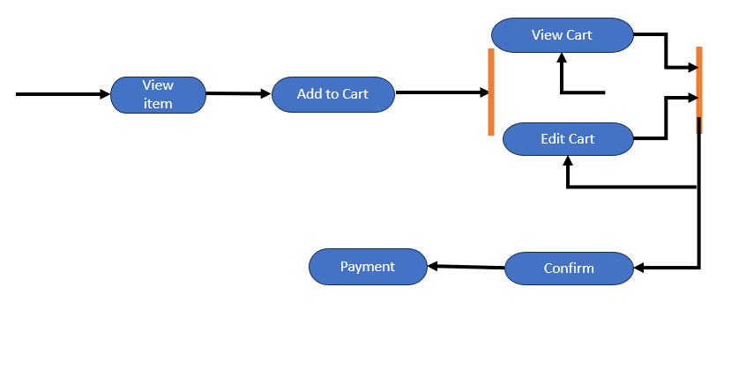

**Roles and Responsibilities:**

|  |  |  |
| --- | --- | --- |
| **Roll No.** | **Name of Student** | **Roles & Responsibilities**  **[Developer / Tester & Associate]** |
| 3057 | Vishal Vitthal Lohar | Associate |
| 3059 | Abhishek Sambhaji Patil | Developer |
| 3060 | Purushottam Santosh Patil | Developer |
| 3067 | Prasad Sanjay Shinde | Developer |
| 3071 | Suhas Shivanand Uttare | Tester |
| 3073 | Omkar Sanjay Yadav | Tester |

**Project Completion Plan:**

|  |  |  |  |
| --- | --- | --- | --- |
| **Sr.no** | **Activity Name** | **Start Date** | **Completed Date** |
| 1 | Team Formation |  |  |
| 2 | Project Finalization |  |  |
| 3 | Synopsis Report |  |  |
| 4 | SRS Reports |  |  |
| 5 | Development & Testing Report -1 |  |  |
| 6 | Development & Testing Report - 2 |  |  |
| 7 | Development & Testing Report - 3 |  |  |
| 8 | Development & Testing Report - 4 |  |  |
| 9 | Development & Testing Report - 5 |  |  |
| 10 | Project Report |  |  |

**Date:**

**Place:**

**Team Leader:**

|  |  |  |
| --- | --- | --- |
| **Roll No.** | **Name of Student** | **Signature** |
| 3059 | Abhishek Sambhaji Patil |  |

**Team Members:**

|  |  |  |
| --- | --- | --- |
| **Roll No.** | **Name of Student** | **Signature** |
| 3057 | Vishal Vitthal Lohar |  |
| 3060 | Purushottam Santosh Patil |  |
| 3067 | Prasad Sanjay Shinde |  |
| 3071 | Suhas Shivanand Uttare |  |

**Guide Sign. HOD Sign.**